Material Safety Data Sheet (MSDS) – TUFFSTUFF Granules (Hardener)

Conforms to regulation (EC) 1907/2006 (REACH), annex II as amended by Regulation (EU) 453/2010

Identification of the Substance/Mixture and of the Company/Undertaking

Product identifier
Trade Name: TuffStuff Granules (Hardener)

Relevant identified uses of the substance or mixture and uses advised against
Industrial uses: Catalyst for use with liquid applied roof waterproofing systems.
Professional uses: Catalyst for use with liquid applied roof waterproofing systems.
Uses advised against: Product is not for consumer use.

Details of the supplier of the safety data sheet
Tuff Waterproofing Ltd
Unit 5, First Avenue
Sherburn in Elmet
LS25 6PD
Tel; 01977 680250
Email: orders@tuffwaterproofing.co.uk

Emergency telephone number
01977 680250

Hazards Identification

Classification of the substance or mixture
Product definition: Mixture

Classification according to Regulation (EC) No. 1272/2008 [CLP/GHS]

Organic Peroxide, (Type D), H242
Eye Irritation, category 2, H319
Reproductive Toxicity, category 2, H361f
Aquatic Environment, Chronic, Category 1, H410
Aquatic Environment, Acute, Category 1, H400
Skin Sensitisation, Category 1, H317

See Section 16 for the full text of the H statements declared above.

Label elements
Hazard Pictograms:

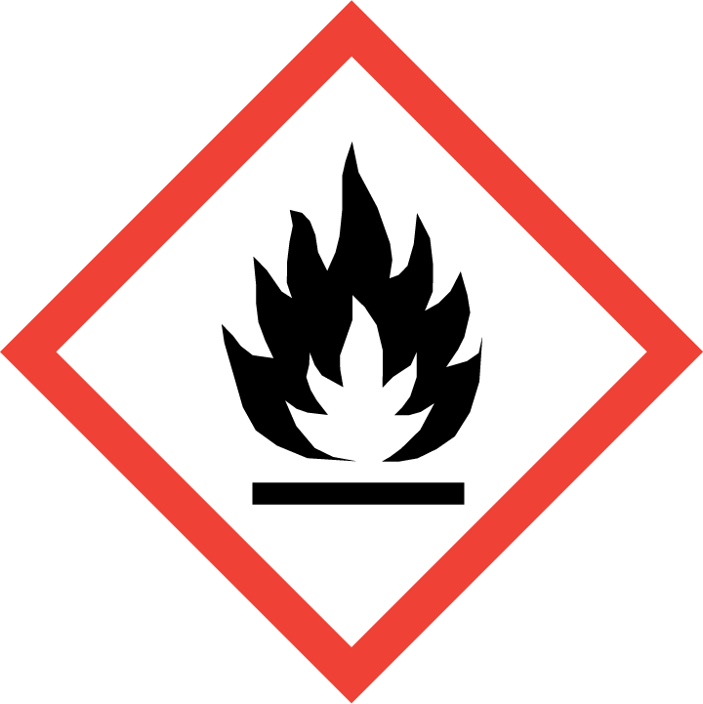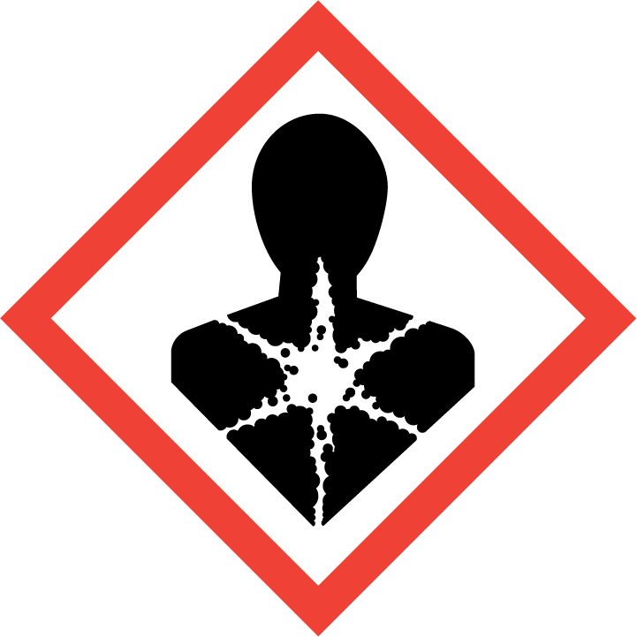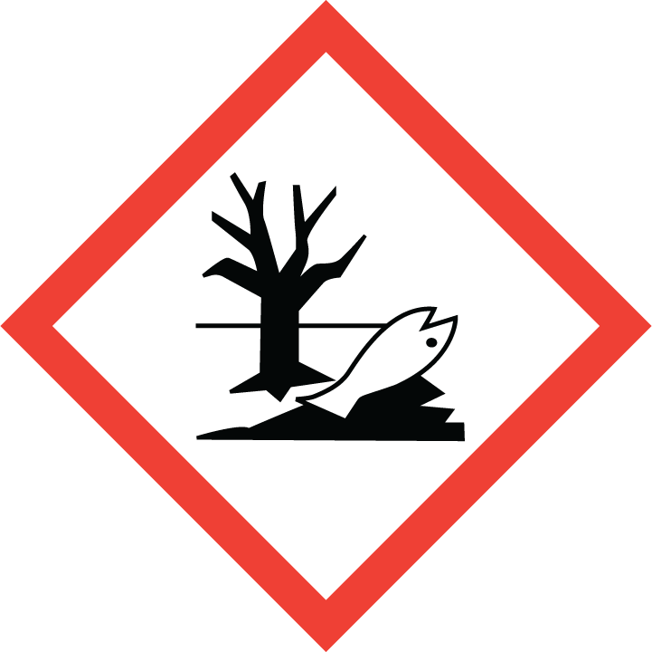

Signal word: DANGER

Hazard Statements

Heating may cause a fire.
May cause an allergic skin reaction.
Causes serious eye irritation.
Suspected of damaging fertility, or the unborn child.
Very toxic to aquatic life with long lasting effects.

Precautionary Statements

Prevention
Keep away from heat, sparks, open flames and hot surfaces. - No smoking.
Keep away from dirt, rust, chemicals.
Keep in original container
Avoid release to the environment
Wear protective gloves/eye protection/face protection
Use personal protective equipment as required

Response
IF ON SKIN: wash with plenty of soap and water.
IF IN EYES: Rinse cautiously with water for several minutes. Remove contact lenses, if present and easy to do. Continue rinsing.
If exposed or concerned: get medical advice/attention.
Wash hands and contaminated skin thoroughly after handling.

Supplement Statements
Not applicable.

Storage
Store in a well-ventilated place.
Protect from sunlight.

Disposal
Dispose of contents and container in accordance with all local, regional, national and international regulations.

Hazardous Components which must be listed on the label:
Dibenzoyl peroxide
Dicyclohexyl phthalate

Composition and Information on Ingredients

Ingredient Name | Concentration % | Regulation (EC) No.  1272/2008 [CLP]
Dibenzoyl Peroxide  REACH#: 01-2119511472-50  EC: 202-327-6  CAS: 94-36-0  Index: 617-008-00-0 | 49-51 | Org Perox, B, H241  Eye Irrit,2 , H319  Skin Sens, 1, H317  Aquatic Acute, 1, H400  Aquatic Chronic 1, H410
Dicyclohexyl phthalate  REACH#: 01-2119978223-34-0001  EC: 201-545-9  CAS: 84-61-7 | 40-50 | Repro. 2, H316f  Skin Sens, 1, H317  Aquatic Acute 3, H412  Aquatic Chronic 3, H412

Refer to Section 16 for additional wording.

There are no additional ingredients present which, within the current knowledge of the supplier and in the concentrations applicable, are classified as hazardous to health or the environment, are PBTs or vPvBs or have been assigned a workplace exposure limit and hence require reporting in this section.

First Aid Measures

Description of first aid measures

General
In all cases of doubt, or when symptoms persist, seek medical attention. Never give anything by mouth to an unconscious person. If unconscious, place in recovery position and seek medical advice.

Eye Contact
Immediately flush eyes with plenty of water. If easy to do, contact lenses should be removed during the flushing, by trained personnel. Hold the eyelids apart during the flushing to ensure rinsing the entire surface of the eye and lids with water. Get medical attention if irritation persists.

Inhalation
Remove to fresh air. If not breathing, give artificial respiration. Oxygen may additionally be given, by trained personnel, if it is available. Get medical attention if symptoms occur.

Skin Contact
Immediately wash skin with soap and plenty of water. Remove contaminated clothing and shoes. Get medical attention if symptoms occur. Wash clothing before reuse. Thoroughly clean or destroy contaminated shoes.

Ingestion
Call a physician or a poison control center immediately. Induce vomiting only if directed by medical personnel. The patient should lie on their left side while vomiting to reduce the risk of aspiration. Never give anything by mouth to an unconscious or convulsing person.

Protection of First Aiders
No action shall be taken involving any personal risk or without suitable training. It may be dangerous to the person providing aid to give mouth-to-mouth resuscitation.

Most Important symptoms and effects, both acute and delayed
Irritating to eyes.
May cause sensitization by skin contact.
Possible risk of impaired fertility.

Indication of any immediate medical attention and special treatment needed
Notes to Physician:
Persons with pre-existing skin, respiratory, and/or central nervous system disease may be at increased risk if exposed to this material.

Condition of the patient should be carefully monitored. Aspiration of this product during induced emesis can result in lung injury. If evacuation of stomach contents is considered necessary, use method least likely to cause aspiration, such as gastric lavage after endotracheal intubation. Contact a Poison Control Center for additional treatment information. Treat patient symptomatically

Specific Treatments: No specific treatment

Fire Fighting Measures

Extinguishing media
Suitable extinguishing agents
Recommended: sand, alcohol-resistant foam, CO₂, powders, water spray.
For safety reasons unsuitable extinguishing agents:
Halones

Special hazards arising from the substance or mixture
Fire will produce dense black smoke. Exposure to decomposition products may cause a health hazard. Decomposition products may include the following materials: carbon monoxide, carbon dioxide, smoke, benzoic acid, benzene.

Advice for firefighters
Protective equipment
Firefighters must wear fire resistant protective equipment. Wear approved respirator and protective gloves.

Other Information
Evacuate all non-essential personnel. Extinguish a small fire with powder or carbon dioxide then apply water to prevent re-ignition. Cool closed containers with water. Water used to extinguish a fire should not be allowed to enter the drainage system or water courses. After a fire, ventilate thoroughly the area and soak with water, clean the walls and metallic surfaces.

Fire and explosion hazard
CAUTION: reignition may occur. Decomposition under effect of heating (See also Section Hazardous decomposition products). If involved in a fire, it will support combustion. Dust explosion hazard. In case of fire and/or explosion do not breathe fumes.

Accidental Release Measures

Personal Precautions protective equipment and emergency procedures
Exclude sources of ignition and ventilate the area. Avoid breathing vapour or mist.
Refer to protective measures listed in sections 7 and 8. If specialised clothing is required to deal with the spillage, take note of any information in Section 8 on suitable and unsuitable materials.

Environmental precautions
Do not allow to enter drains or watercourses. If the product contaminates lakes, rivers, or
sewers, inform the appropriate authorities in accordance with local regulations.

Methods and material for containment and cleaning up
Stop leakage if possible. Eliminate all sources of ignition, and do not generate flames or sparks. First moisten with water. Sweep up and put it into a container for disposal. Avoid dust generation. Keep contents moist. The waste should NOT be confined. Flush surroundings with large amounts of water and soap.

Reference to other sections
See Section 1 for emergency contact information.
See Section 8 for information on appropriate personal protective equipment.
See Section 13 for additional waste treatment information

Other information
CAUTION: reignition may occur. Evacuate personnel to safe area.

Handling and Storage

Precautions for Safe Handling
Protective Measures & Advice on General Occupational hygiene
Never weigh out in the storage room. When using do not eat, drink or smoke. Do not breathe dust. Handle in well ventilated areas. Eliminate all sources of ignition, and do not generate flames or sparks. Keep away from reducing agents (e.g. amines), acids, alkalies and heavy metal compounds (e.g. accelerators, driers, metal soaps). Keep product and emptied container away from heat and sources of ignition. Confinement must be avoided. Do not allow to dry out. Avoid contact with skin and eyes. Avoid Incompatible materials (See Section 10)
Always keep in containers made from the same material as the original one.

Information on fire and explosion protection
Avoid dust generation. Dust explosion possible in the presence of air. Use non-sparking tools in areas where explosive dust air mixtures may occur. Do not cut or weld on or near this container even when empty.

Conditions for safe storage, including incompatibilities
Store in accordance with local/national regulations. Keep away from food, drink and animal feeding stuffs. Store in a dry well ventilated place away from sources of heat and direct sunlight. Store separate from other chemicals. Keep only in the original container.

For maximum quality store below 25 °C

Specific end use(s)
Not Available

Other information
It is recommended to use electrical equipment of temperature group T3. However, autoignition can never be excluded.
Wash hands thoroughly after handling or contact. Keep working clothing separately and do not take them home.

Exposure Controls / Personal Protection

Control parameters

Product/ingredient name | Exposure limit values
Dibenzoyl peroxide | EH40/2005 WELs (United Kingdom (UK), 12/2011).  STEL: 15 mg/m³ 15 minutes.(calculated  TWA: 5 mg/m³ 8 hours.
Dicyclohexyl phthalate | EH40/2005 WELs (United Kingdom (UK), 12/2011).  STEL: 15 mg/m³ 15 minutes.(calculated  TWA: 5 mg/m³ 8 hours.

Recommended monitoring procedures
If this product contains ingredients with exposure limits, personal, workplace atmosphere or biological monitoring may be required to determine the effectiveness of the ventilation or other control measures and/or the necessity to use respiratory protective equipment.
Reference should be made to monitoring standards, such as the following: European Standard.
EN 689 (Workplace atmospheres - Guidance for the assessment of exposure by inhalation to chemical agents for comparison with limit values and measurement strategy) European Standard.
EN 14042 (Workplace atmospheres - Guide for the application and use of procedures for the
Assessment of exposure to chemical and biological agents) European Standard EN 482.
(Workplace atmospheres - General requirements for the performance of procedures for the measurement of chemical agents) Reference to national guidance documents for methods for the determination of hazardous substances will also be required.

DNELs/DMELs

Product/ingredient name | Type | Exposure | Value | Population | Effects
Dibenzoyl Peroxide | DNEL  DNEL  DNEL  DNEL  DNEL | Long Term Inhalation  Long Term Dermal  Long Term Inhalation  Long Term Dermal  Long Term Oral | 11.75 mg/m³  6.6 mg/kg bw/day  2.9 mg/m³  3.3 mg/kg bw/day  1.65 mg/kg bw/day | Workers  Workers  Consumers  Consumers  Consumers | Systemic  Systemic  Systemic  Systemic  Systemic
Dicyclohexyl phthalate | DNEL  DNEL  DNEL  DNEL  DNEL  DNEL  DNEL  DNEL | Dermal Acute  Inhalation Acute  Long Term Inhalation  Long Term Dermal  Inhalation Acute  Long Term Inhalation  Long Term Dermal  Long Term Oral | 0.5 mg/kg bw/day  35.2 mg/m³  35.2 mg/m³  0.5 mg/kg bw/day  0.87 mg/m³  0.87 mg/m³  0.25 mg/kg bw/day  0.25 mg/kg bw/day | Workers  Workers  Workers  Workers  Consumers  Consumers  Consumers  Consumers | Systemic  Systemic  Systemic  Systemic  Systemic/Local  Systemic  Systemic  Systemic

PNECs

Product/ingredient name | Compartment Detail | Value | Method detail
Benzoyl Peroxide | Fresh Water  Marine Water  Intermittent Release  Sewerage Treatment Plant  Fresh Water Sediment  Soil  Oral | 0.000602 mg/l  0.000602 mg/l  0.000602 mg/l  0.35 mg/l  0.338 mg/kg  0.0758 mg/kg  6.67 mg/kg (food) | -  -  -  -  -  -  -
Dicyclohexyl phthalate | Fresh Water  Marine Water  Intermittent Release  Sewerage Treatment Plant  Fresh Water Sediment  Marine Sediment  Soil  Oral | 0.00362 mg/l  0.00362 mg/l  0.00362 mg/l  10 mg/l  1.06 mg/kg  0.106 mg/kg  0.21 mg/kg  133 mg/kg  (food)

Exposure controls

Appropriate engineering controls
Provide adequate ventilation. Where reasonably practicable, this should be achieved by the use of local exhaust ventilation and good general extraction. If these are not sufficient to maintain concentrations of particulates and solvent vapours below the OEL, suitable respiratory protection must be worn. (Respirator filter P1).
Explosion Proof ventilation is recommended.

Personal protective equipment
General protective and hygienic measures
Wash hands, forearms and face thoroughly after handling chemical products, before eating, smoking and using the lavatory and at the end of the working period. Appropriate techniques should be used to remove potentially contaminated clothing. Wash contaminated clothing before reusing. Ensure that eyewash stations and safety showers are close to the workstation location.

Breathing equipment
If workers are exposed to concentrations above the exposure limit, they must use appropriate, certified respirators. Use a properly fitted, air-purifying or air-fed respirator complying with an approved standard if a risk assessment indicates this is necessary. Respirator selection must be based on known or anticipated exposure levels, the hazards of the product and the safe working limits of the selected respirator. Recommended: Respirator filter P1.

Protection of hands
There is no one glove material or combination of materials that will give unlimited resistance to any individual or combination of chemicals.
The breakthrough time must be greater than the end use time of the product.
The instructions and information provided by the glove manufacturer on use, storage, maintenance and replacement must be followed.
Gloves should be replaced regularly and if there is any sign of damage to the glove material.
Always ensure that gloves are free from defects and that they are stored and used correctly.
The performance or effectiveness of the glove may be reduced by physical/chemical damage and poor maintenance.
Barrier creams may help to protect the exposed areas of the skin but should not be applied once exposure has occurred.

Material of gloves
For prolonged or repeated handling, use the following type of gloves:
Recommended: Neoprene or synthetic rubber
The recommendation for the type or types of glove to use when handling this product is based on information from the following source: EN 374-3 : 2003.
The user must check that the final choice of type of glove selected for handling this product is the most appropriate and takes into account the particular conditions of use, as included in the user's risk assessment.

Eye protection
Safety glasses with side shields. (EN166)

Body Protection
Personnel should wear antistatic clothing made of natural fibres or of high temperature-resistant synthetic fibres. (EN 1149-1)

Physical and Chemical Properties

Information on basic physical and chemical properties
General Information

Appearance:
Form: Free Flowing powder
Colour: White
Odour: Faint
Odour threshold: Not Available
pH-value: Not Applicable
Change in condition
Melting point/Melting range: Not Available
Initial Boiling point/Boiling range: Decomposes
Flash point: Not Applicable
Evaporation Rate: Not Available
Flammability (solid, gaseous) Not Available
Critical values for explosion:
Lower: Not Available
Upper: Not Available
Vapour pressure at 20°C: Not Available
Vapour density: Not Applicable
Relative Density: 1.23g/cm3 (20°C)
Solubility in / Miscibility with Water: Insoluble in water
Partition coefficient (n-octanol/water): Not Available
Auto Ignition temperature: Not Available
Decomposition Temperature: Not Available
Viscosity: Not Applicable
Explosive Properties: Not Available
Oxidising Properties: Not Available
SADT 55°C
Active Oxygen content 3.3%
Peroxide Content 48-55%

Other information
No Additional Information

Stability and Reactivity

Reactivity
No specific test data related to reactivity available for this product or its ingredients.

Chemical stability
SADT - (Self accelerating decomposition temperature) is the lowest temperature at which self- accelerating decomposition may occur with a substance in the packaging as used in transport.
A dangerous self-accelerating decomposition reaction and, under certain circumstances, explosion or fire can be caused by thermal decomposition at and above the following temperature: 55 °C.
Contact with incompatible substances can cause decomposition at or below the SADT 55 °C.

Possibility of hazardous reactions
Under normal conditions of storage and use, hazardous reactions will not occur.

Conditions to avoid
To maintain quality store in original closed container below: 25 °C.
Avoid shock and friction. Confinement must be avoided. Do not allow to dry out. Explosive when dry.

Incompatible materials:
Avoid contact with rust, iron and Copper. Contact with incompatible materials such as acids, alkalis, heavy metals and reducing agents will result in hazardous decomposition. Do not mix with peroxide accelerators. Use only Stainless steel 316, PP, polyethylene or glass-lined equipment.

Hazardous decomposition products:
Under normal conditions of storage and use, hazardous decomposition products should not be
produced. If involved in a fire, toxic gases including CO, CO2, smoke, benzoic acid, benzene can be generated.

Other information
Emergency procedures will vary depending on conditions. The customer must have an emergency response plan in place.

Toxicological Data

Information on toxicological effects
There is no data available on the mixture itself.

Acute Toxicity

Product/ingredient Name | Result | Species | Dose | Exposure
Dibenzoyl Peroxide | LD50 Oral  LC50 Inhalation | Rat  Rat | >5000 mg/kg  >24300 mg/m3 (dust) | -
Dicyclohexyl phthalate | LD50 Oral  LD50 Dermal | Rat  Rat | >2000 mg/kg  >2000 mg/kg

Conclusion/Summary: Not Available
Acute toxicity estimates: Not available

Irritation/Corrosion

Product/ingredient Name | Result | Species | Score | Exposure | Observation
Dibenzoyl Peroxide | Minimally Irritating  Eye Irritant | Rabbit | -
Dicyclohexyl phthalate | Non Irritating | -

Conclusion/Summary: Not Available

Sensitisation

Product / Ingredient Name | Route of exposure | Species | Result
Dibenzoyl Peroxide | Skin | - | Sensitizing
Dicyclohexyl phthalate | Skin | Mouse (LLNA test) | Sensitising

Conclusion/Summary
Skin: Sensitising
Respiratory: Not Available

Mutagenicity

Product / Ingredient Name | Test | Experiment | Result
Dibenzoyl Peroxide |  |  | Negative
Dicyclohexyl phthalate |  | Experiment : In Vitro | Negative

Conclusion/Summary: Based on available data, the classification criteria are not met.

Carcinogenicity/Chronic Toxicity

Product / Ingredient name | Result | Species | Dose | Exposure
Dibenzoyl Peroxide | No Observed Adverse Effect Level (NOAEL)  No Observed Adverse Effect Level (NOAEL) | -  - | 1000mg/Kg/day  500mg/kg/day (Oral) | 29 days
Dicyclohexyl phthalate | No Observed Adverse Effect Level (NOAEL) | Rat | 50mg/Kg/day  (Oral) | Subchronic 90 days

Development Toxicity

Product / Ingredient name | Result | Species | Dose | Exposure
Dicyclohexyl phthalate | No Observed Adverse Effect Level (NOAEL) | Rat | 250mg/Kg/day (Oral)

Fertility

Product / Ingredient name | Result | Species | Dose | Exposure
Dicyclohexyl phthalate | No Observed Adverse Effect Level (NOAEL) | Rat | 16-21mg/Kg/day (Oral)

Specific target organ toxicity (single exposure)
Not available

Specific target organ toxicity (repeated exposure)
Not available

Aspiration Hazard
Not available

Ecological Data

Toxicity
There is no data available on the mixture itself.
Do not allow to enter drains or watercourses.

Product/ingredient Name | Result | Species | Exposure
Dibenzoyl Peroxide | LC50 408 to 0.06 mg/l  EC50 0.11 mg/l  EC50 100 to 0.06 mg/l  EC50 35 mg/l | Fish  Daphnia Magna  Algae  Activated Sludge respiration inhibition test | 96 hours  48 hours  72 hours  -
Dicyclohexyl phthalate | LC50 >2 mg/l  EC50 >2 mg/l  EC50 >2 mg/l  NOEC > 100mg/l | Oryzias Latipes  Daphnia Magna  Pseudokirchneriella subcaptica  Activated Sludge | 96 hours  48 hours  3 days  3 hours
Conclusion/Summary: Based on available data, the classification criteria are not met.

Persistence and degradability

Product/ingredient Name | Aquatic half-life | Photolysis | Biodegradability
Dibenzoyl Peroxide | 2.4 hours at 50°C |  | Inherently Biodegradable
Dicyclohexyl phthalate |  |  | Readily

Bioaccumulative potential

Product/ingredient Name | LogPow | BCF | Potential
Dibenzoyl Peroxide |  | 66.6
Dicyclohexyl phthalate | 4.82 | 85 (estimated)

Mobility in soil
Not Available

Results of PBT and VPvB assessment
Not Available

Other adverse effects;
Very toxic to aquatic organisms. May cause long-term adverse effects in the aquatic environment.

Disposal Considerations

Waste treatment methods
Recommendation
The generation of waste should be avoided or minimised wherever possible. Disposal of this product, solutions and any by-products should at all times comply with the requirements of environmental protection and waste disposal legislation and any regional local authority requirements. Dispose of surplus and non-recyclable products via a licensed waste disposal contractor. Waste should not be disposed of untreated to the sewer unless fully compliant with the requirements of all authorities with jurisdiction.

Hazardous Waste
Yes

Disposal considerations
Do not allow to enter drains or watercourses.
Dispose of according to all federal, state and local applicable regulations.
If this product is mixed with other wastes, the original waste product code may no longer apply and the appropriate code should be assigned.
For further information, contact your local waste authority.

European Waste catalogue (EWC)
16 09 03* Peroxides

Transport Information
 | ADR/RID | IMDG | IATA
14.1 UN Number | UN 3106 | UN 3106 | UN 3106
14.2 Proper Shipping Name | Organic Peroxide , Type D, Solid (Dibenzoyl peroxide) | Organic Peroxide , Type D, Solid (Dibenzoyl peroxide) | Organic Peroxide , Type D, Solid (Dibenzoyl peroxide)
14.3 Transport Class(es) | 5.2 Organic Peroxide  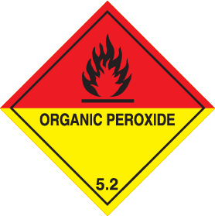 | 5.2 Organic Peroxide | 5.2 Organic Peroxide
14.4 Packing Group | - | - | -
14.5 Environmental Hazards | Yes | Yes | Yes
14.6 Tunnel restriction Code | D | D | D

Marine pollutant: Yes

Special Precautions for user
Transport within user’s premises: always transport in closed containers that are upright and secure. Ensure that persons transporting the product know what to do in the event of an accident or spillage.

Regulatory Information

Safety, health and environmental regulations/legislation specific for the substance or mixture
The information contained in this safety data sheet does not constitute the user’s own assessment of workplace risks, as required by other health and safety legislation. The provisions of the national health and safety at work regulations apply to the use of this product at work.

CN Code: 2916 32 00

EU regulation (EC) 1907/2006 (REACH)
Annex XIV – List of substances subject to authorization

Annex XIV
None of the components are listed
Substances of very high concern
None of the components are listed
Annex XVII – Restrictions on the manufacture, placing on the market and use of certain dangerous substances, mixtures and articles
Not applicable

Other EU Regulations

VOC for Ready-for-use mixture
Not Applicable

Europe inventory
All components are listed or exempted.
National regulations

Chemical Safety Assessment
This product contains substances for which Chemical Safety Assessments are still required.

Other Information
Indicates information that has changed from previously issued version.

Abbreviations and acronyms
ATE = Acute Toxicity Estimate
CLP = Classification, Labelling and Packaging Regulation [Regulation (EC) No.1272/2008]
DMEL = Derived Minimal Effect Level
DNEL = Derived No Effect Level
EUH statement = CLP-specific Hazard statement
PBT = Persistent, Bioaccumulative and Toxic
PNEC = Predicted No Effect Concentration
RRN = REACH Registration Number
vPvB = Very Persistent and Very Bioaccumulative

Procedure used to derive the classification according to regulation (EC) 1272/2008 [CLP/GHS]

Classification | Justification
Org Perox D, H242  Eye Irrit,2, H319  Skin Sens. 1, H317  Aquatic Acute 1, H400  Aquatic Acute 1, H410  Repro 2, H316 | Test Data  Calculation method  Calculation method  Calculation method  Calculation method  Calculation method

Full text of abbreviated H Statements Full text of classifications [CLP/GHS]
H241. Heating may cause a fire or explosion
H242. Heating may cause a fire .
H317. May cause an allergic skin reaction.
H319. Causes serious eye irritation.
H400. Very toxic to aquatic life.
H410. Very toxic to aquatic life with long lasting effects
H361. Suspected of damaging fertility or the unborn child
H412. Harmful to aquatic life with long lasting effects.

Full text of Classifications [CLP/GHS]
Org Perox, D H214 ORGANIC PEROXIDE Type D
Eye Irrit,2, H319 SERIOUS EYE DAMAGE/EYE IRRITATION – Category 2
Skin Sens. 1, H317 SKIN SENSITISATION - Category 1
Aquatic Acute 1, H400 AQUATIC TOXICITY (ACUTE) - Category 1
Aquatic Acute 3, H410 AQUATIC TOXICITY (CHRONIC) - Category 1
Repro 2, H316 REPRODUCTIVE TOXICITY – Category 2

Note
The information contained in the Safety Data Sheet is based on our data available on the date of publication. The information is intended to aid the user in controlling the handling risks; it is not to be construed as a warranty or specification of the product quality.
The information may not be or may not altogether be applicable to combinations of the product with other substances or to particular applications.
The user is responsible for ensuring that appropriate precautions are taken and for satisfying themselves that the data are suitable and sufficient for the product's intended purpose. In case of any unclarity we advise consulting the supplier or an expert.

Date of Issue: 1st July 2021
Version: 1

